Suplementary Material

Long-term changes in population dynamics and life history contribute to explain the resilience of a stock of *Micropogonias furnieri* (Sciaenidae, Teleostei) in the SW Atlantic.

**Authors**

Manuel Haimovici1, Leticia Maria Cavole2, Jason M. Cope³, Luís Gustavo Cardoso1

3.1 Growth changes

Here we present the estimated values for the fitted Von Bertalanffy growth models by sex and for each period (Tables 1 and 2). The Figures 1 to 6 shows the trace plots of the evolution of the parameter vectors over the iterations of the three Markov chains and the respective the parameters posterior distributions.

Table 1. The posterior parameters for von Bertalanffy’s growth model (*L∞, k,* *t0* and *sigma*) estimated for females of *Micropogonias furnieri* from southern Brazil for five periods (1:1978, 2:1989-1992, 3: 1999-2003, 4: 2007-2010, 5:2014-2017). Sd= standard deviation. Overlap0 checks if 0 falls in the parameter's 95% credible interval. *f* is the proportion of the posterior with the same sign as the mean; i.e., our confidence that the parameter is positive or negative.. Successful convergence based on Rhat values (all < 1.1). Rhat is the potential scale reduction factor (at convergence, Rhat=1). For each parameter, n.eff is a crude measure of effective sample size.

|  |  |  |  |  |  |  |  |  |  |
| --- | --- | --- | --- | --- | --- | --- | --- | --- | --- |
|  | Mean | sd | 2.5% | 50% | 97.5% | Overlap0 | f | Rhat | n.eff |
| linf[1] | 556.025 | 8.613 | 540.538 | 555.559 | 573.815 | FALSE | 1 | 1.002 | 929 |
| linf[2] | 592.726 | 5.335 | 582.391 | 592.719 | 603.453 | FALSE | 1 | 1.001 | 1864 |
| linf[3] | 681.252 | 8.104 | 666.256 | 681.138 | 697.744 | FALSE | 1 | 1.002 | 1434 |
| linf[4] | 660.079 | 7.72 | 645.525 | 659.944 | 675.522 | FALSE | 1 | 1.001 | 2334 |
| linf[5] | 676.265 | 8.054 | 660.819 | 676.058 | 692.799 | FALSE | 1 | 1 | 6000 |
| t0[1] | -3.671 | 0.631 | -5 | -3.643 | -2.541 | FALSE | 1 | 1.004 | 565 |
| t0[2] | -1.077 | 0.159 | -1.402 | -1.069 | -0.78 | FALSE | 1 | 1.003 | 689 |
| t0[3] | -0.179 | 0.086 | -0.36 | -0.174 | -0.026 | FALSE | 1 | 1.003 | 641 |
| t0[4] | -0.025 | 0.024 | -0.089 | -0.018 | -0.001 | FALSE | 1 | 1 | 6000 |
| t0[5] | -0.289 | 0.1 | -0.487 | -0.286 | -0.103 | FALSE | 1 | 1.002 | 4555 |
| k[1] | 0.145 | 0.016 | 0.116 | 0.144 | 0.178 | FALSE | 1 | 1.003 | 723 |
| k[2] | 0.218 | 0.01 | 0.198 | 0.217 | 0.238 | FALSE | 1 | 1.004 | 637 |
| k[3] | 0.239 | 0.01 | 0.219 | 0.239 | 0.258 | FALSE | 1 | 1.003 | 678 |
| k[4] | 0.303 | 0.009 | 0.286 | 0.303 | 0.321 | FALSE | 1 | 1 | 3808 |
| k[5] | 0.253 | 0.012 | 0.231 | 0.253 | 0.276 | FALSE | 1 | 1.002 | 4427 |
| sigma[1] | 0.102 | 0.004 | 0.096 | 0.102 | 0.11 | FALSE | 1 | 1 | 6000 |
| sigma[2] | 0.128 | 0.003 | 0.122 | 0.128 | 0.135 | FALSE | 1 | 1 | 6000 |
| sigma[3] | 0.119 | 0.003 | 0.113 | 0.119 | 0.126 | FALSE | 1 | 1 | 6000 |
| sigma[4] | 0.146 | 0.003 | 0.139 | 0.146 | 0.153 | FALSE | 1 | 1 | 4422 |
| sigma[5] | 0.097 | 0.003 | 0.092 | 0.097 | 0.103 | FALSE | 1 | 1 | 6000 |
| deviance | 36959.96 | 6.505 | 36949.24 | 36959.26 | 36974.36 | FALSE | 1 | 1 | 6000 |

Table 2. The posterior parameters for von Bertalanffy’s growth model (*L∞, k,* *t0* and *sigma*) estimated for males of *Micropogonias furnieri* from southern Brazil for five periods (1:1978, 2:1989-1992, 3: 1999-2003, 4: 2007-2010, 5:2014-2017). Sd= standard deviation. Overlap0 checks if 0 falls in the parameter's 95% credible interval. *f* is the proportion of the posterior with the same sign as the mean; i.e., our confidence that the parameter is positive or negative.. Successful convergence based on Rhat values (all < 1.1). Rhat is the potential scale reduction factor (at convergence, Rhat=1). For each parameter, n.eff is a crude measure of effective sample size.

|  |  |  |  |  |  |  |  |  |  |
| --- | --- | --- | --- | --- | --- | --- | --- | --- | --- |
|  | Mean | sd | 3% | 50% | 97.50% | Overlap0 | f | Rhat | n.eff |
| linf[1] | 489.591 | 8.692 | 474.41 | 488.906 | 507.737 | FALSE | 1 | 1.019 | 129 |
| linf[2] | 563.918 | 8.538 | 547.557 | 563.767 | 581.135 | FALSE | 1 | 1 | 3525 |
| linf[3] | 668.626 | 11.444 | 646.865 | 668.298 | 691.916 | FALSE | 1 | 1.002 | 3387 |
| linf[4] | 619.76 | 7.853 | 605.104 | 619.635 | 634.896 | FALSE | 1 | 1.007 | 2331 |
| linf[5] | 652.466 | 15.623 | 625.977 | 651.656 | 682.777 | FALSE | 1 | 1.017 | 590 |
| t0[1] | -3.062 | 0.826 | -4.9 | -2.989 | -1.651 | FALSE | 1 | 1.026 | 99 |
| t0[2] | -1.04 | 0.216 | -1.489 | -1.03 | -0.65 | FALSE | 1 | 1.002 | 1916 |
| t0[3] | -0.152 | 0.103 | -0.389 | -0.136 | -0.008 | FALSE | 1 | 1.002 | 1172 |
| t0[4] | -0.039 | 0.043 | -0.133 | -0.028 | -0.001 | FALSE | 1 | 1.04 | 5427 |
| t0[5] | -0.584 | 0.138 | -0.855 | -0.576 | -0.345 | FALSE | 1 | 1.009 | 1014 |
| k[1] | 0.197 | 0.032 | 0.141 | 0.195 | 0.263 | FALSE | 1 | 1.019 | 114 |
| k[2] | 0.239 | 0.017 | 0.207 | 0.238 | 0.273 | FALSE | 1 | 1.002 | 1936 |
| k[3] | 0.229 | 0.012 | 0.206 | 0.229 | 0.251 | FALSE | 1 | 1.003 | 1580 |
| k[4] | 0.346 | 0.012 | 0.323 | 0.346 | 0.368 | FALSE | 1 | 1.007 | 1706 |
| k[5] | 0.237 | 0.016 | 0.206 | 0.237 | 0.268 | FALSE | 1 | 1.008 | 525 |
| sigma[1] | 0.101 | 0.004 | 0.093 | 0.101 | 0.111 | FALSE | 1 | 1 | 6000 |
| sigma[2] | 0.131 | 0.004 | 0.123 | 0.131 | 0.14 | FALSE | 1 | 1 | 6000 |
| sigma[3] | 0.135 | 0.004 | 0.127 | 0.135 | 0.144 | FALSE | 1 | 1.001 | 2367 |
| sigma[4] | 0.132 | 0.003 | 0.126 | 0.132 | 0.139 | FALSE | 1 | 1 | 6000 |
| sigma[5] | 0.099 | 0.004 | 0.092 | 0.099 | 0.106 | FALSE | 1 | 1 | 6000 |
| deviance | 27058.19 | 7.777 | 27047.09 | 27057.35 | 27072.46 | FALSE | 1 | 1.045 | 1194 |

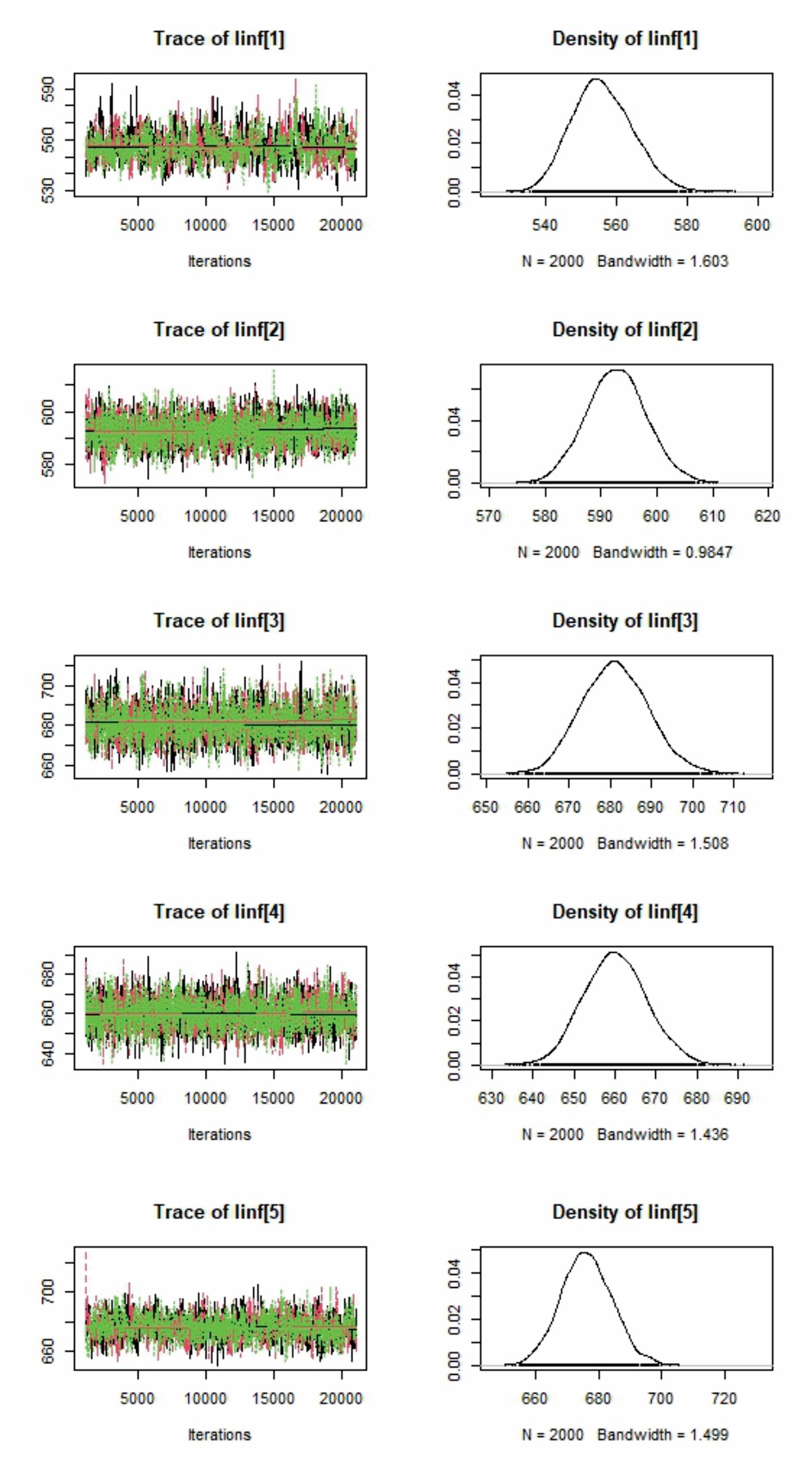

Figure 1. Females MCMC diagnostic plots for the von Bertalanffy Linf parameter for five periods (1:1978, 2:1989-1992, 3: 1999-2003, 4: 2007-2010, 5:2014-2017) and its respective posterior distributions.

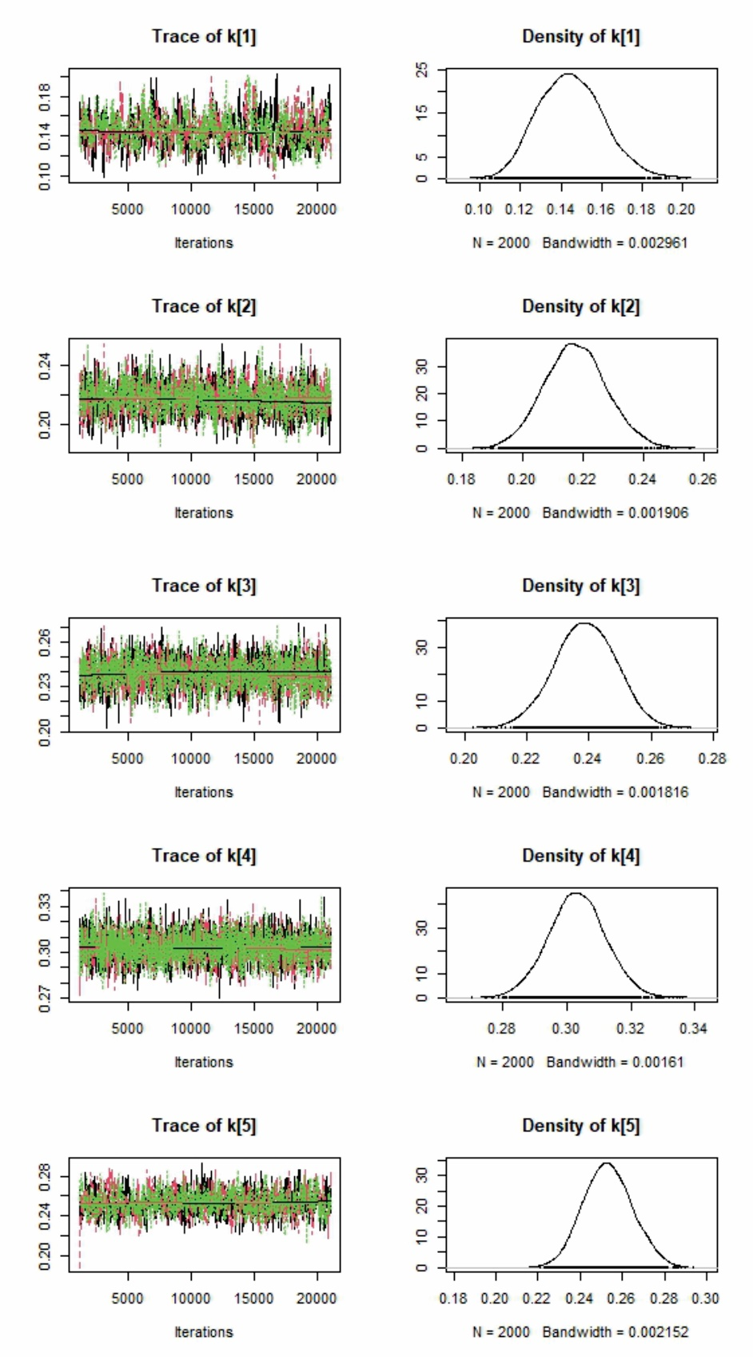

Figure 2. Females MCMC diagnostic plots for the von Bertalanffy k parameter for five periods (1:1978, 2:1989-1992, 3: 1999-2003, 4: 2007-2010, 5:2014-2017) and its respective posterior distributions.

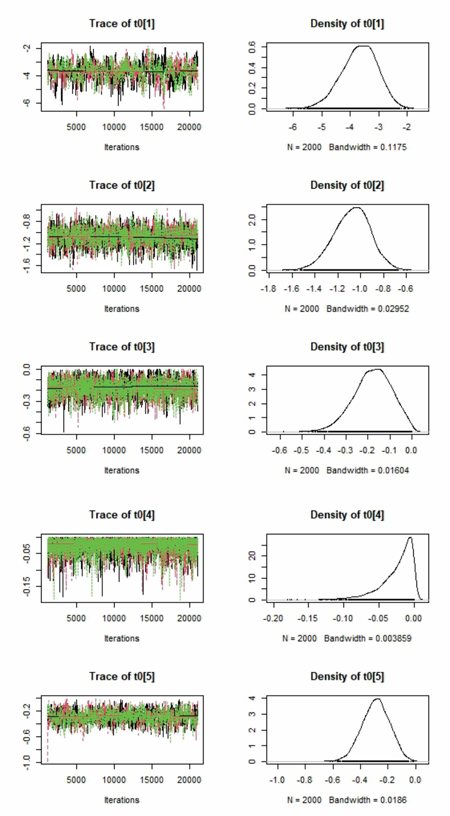

Figure 3. Females MCMC diagnostic plots for the von Bertalanffy t0 parameter for five periods (1:1978, 2:1989-1992, 3: 1999-2003, 4: 2007-2010, 5:2014-2017) and its respective posterior distributions.

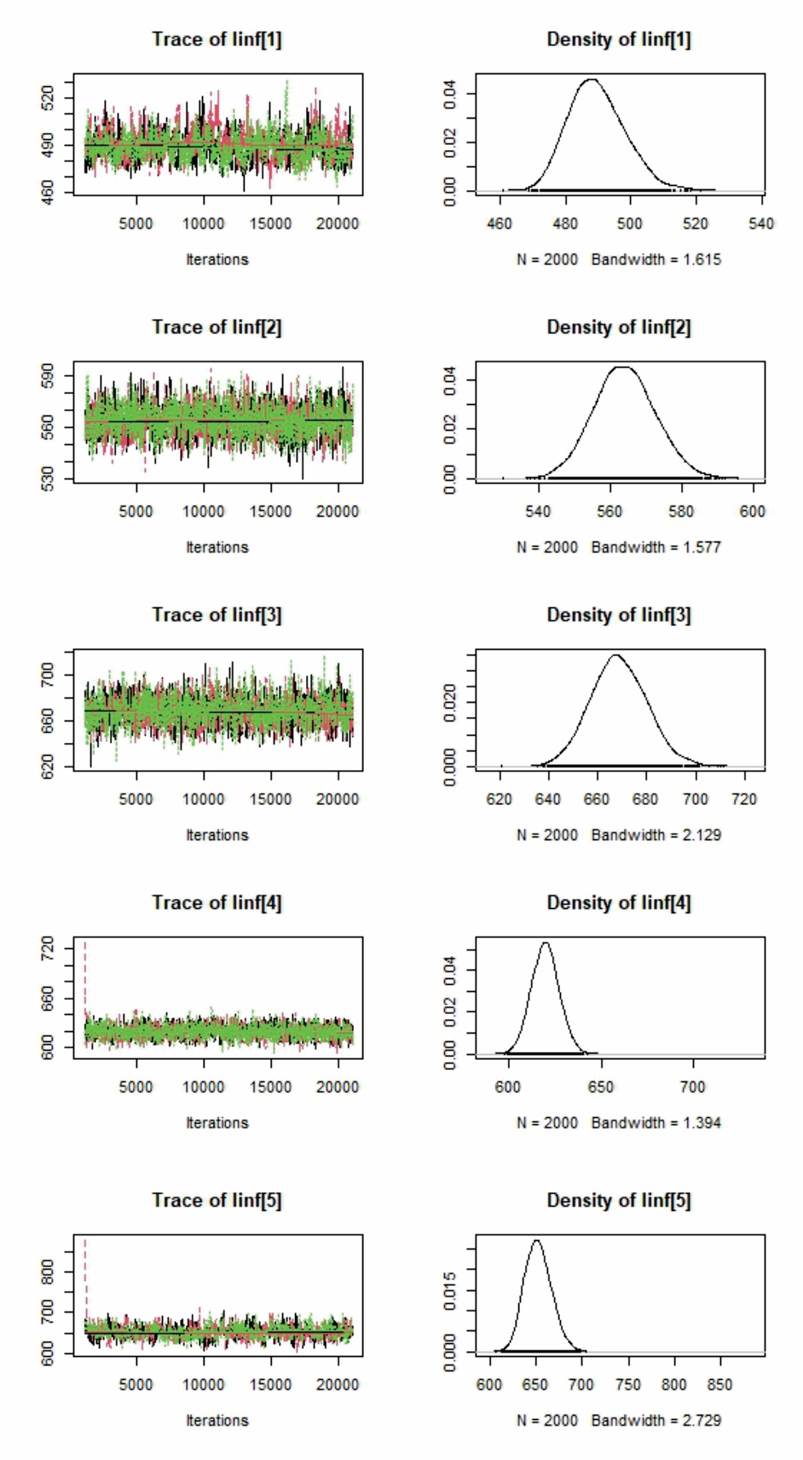

Figure 4. Males MCMC diagnostic plots for the von Bertalanffy Linf parameter for five periods (1:1978, 2:1989-1992, 3: 1999-2003, 4: 2007-2010, 5:2014-2017) and its respective posterior distributions.

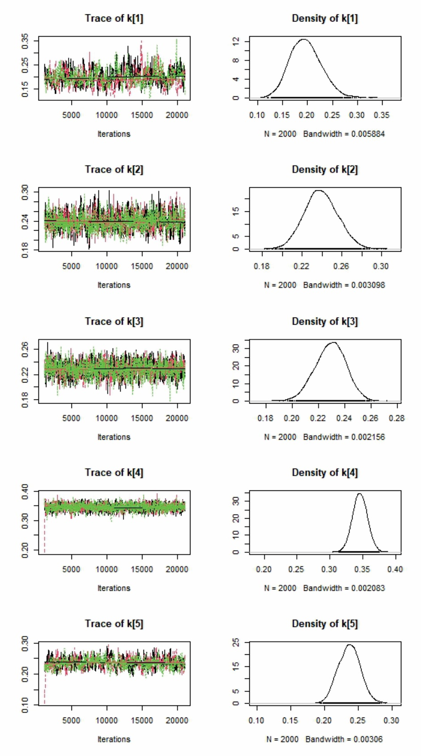

Figure 5. Males MCMC diagnostic plots for the von Bertalanffy k parameter for five periods (1:1978, 2:1989-1992, 3: 1999-2003, 4: 2007-2010, 5:2014-2017) and its respective posterior distributions.

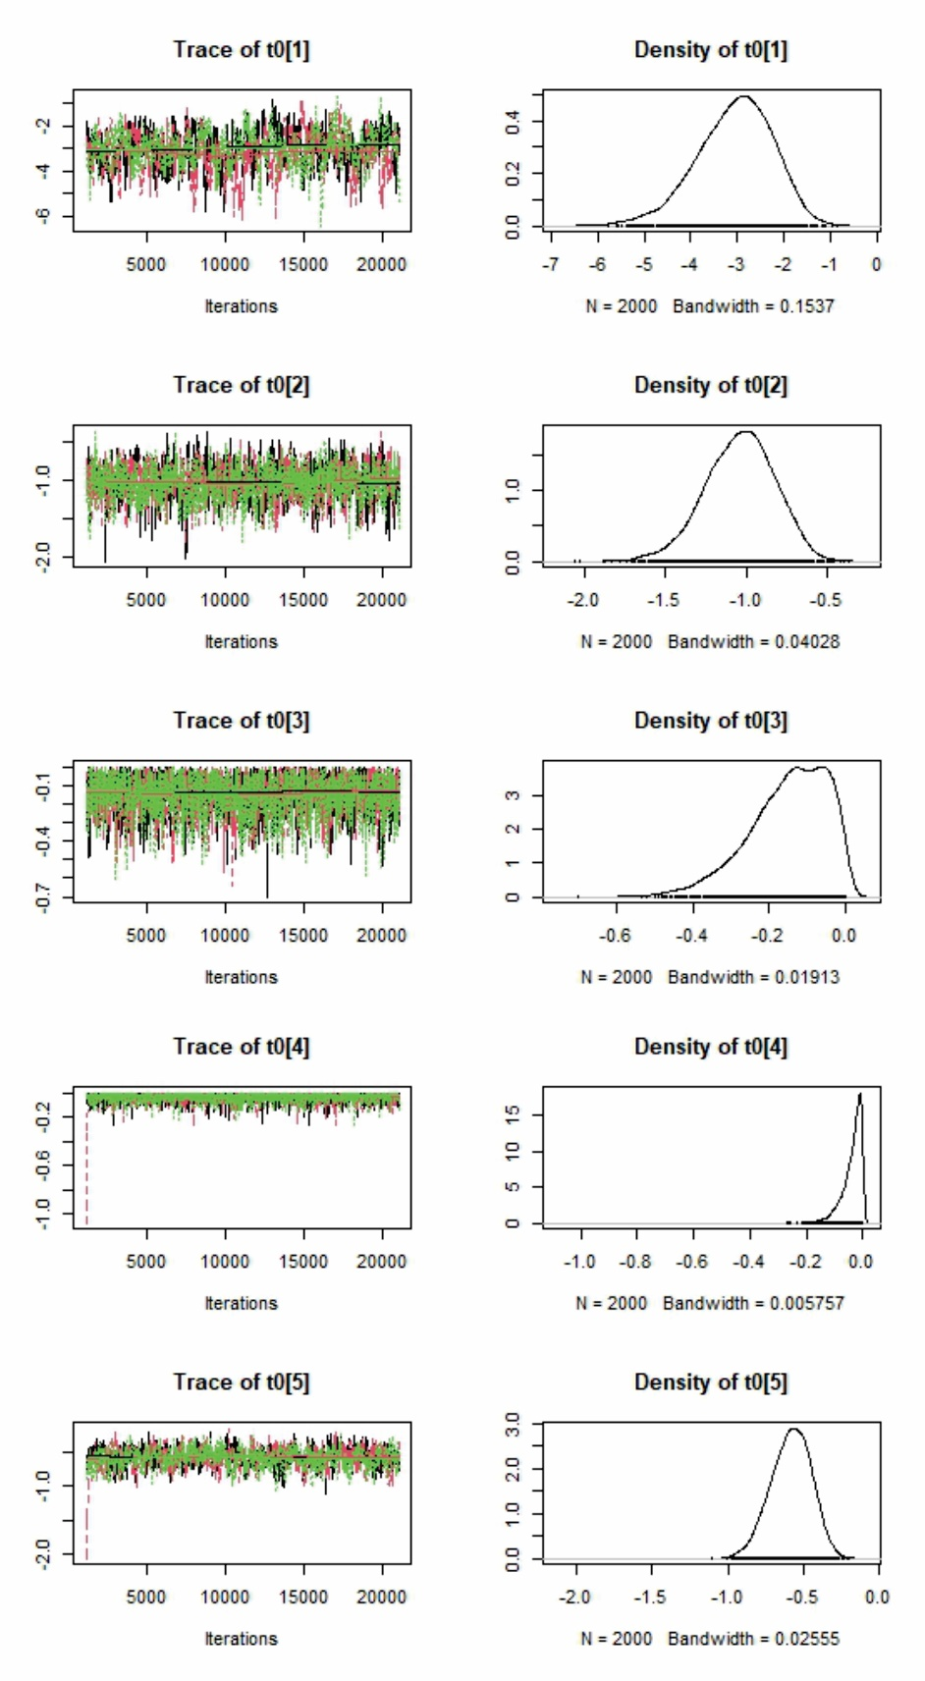

Figure 6. Males MCMC diagnostic plots for the von Bertalanffy t0 parameter for five periods (1:1978, 2:1989-1992, 3: 1999-2003, 4: 2007-2010, 5:2014-2017) and its respective posterior distributions.